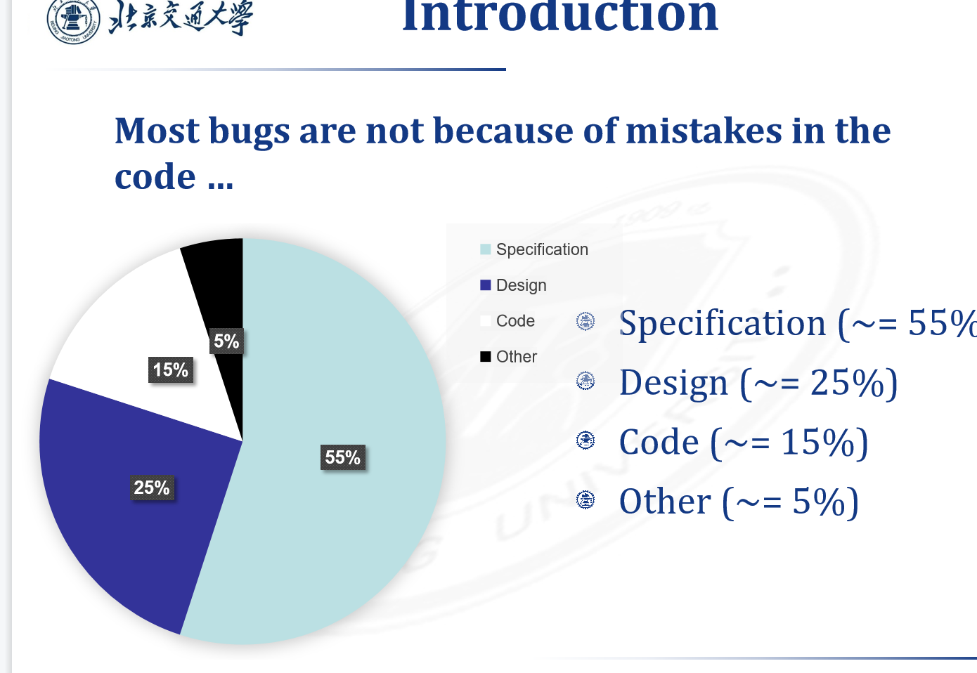

A specification defines the product being created and includes:

Functional requirements that describes the features the product will support. E.g., on a word processor

Save, print, check spelling, change font, …

Non-functional requirements are constraints on the product. E.g,

Security, reliability, user friendliness, platform, …

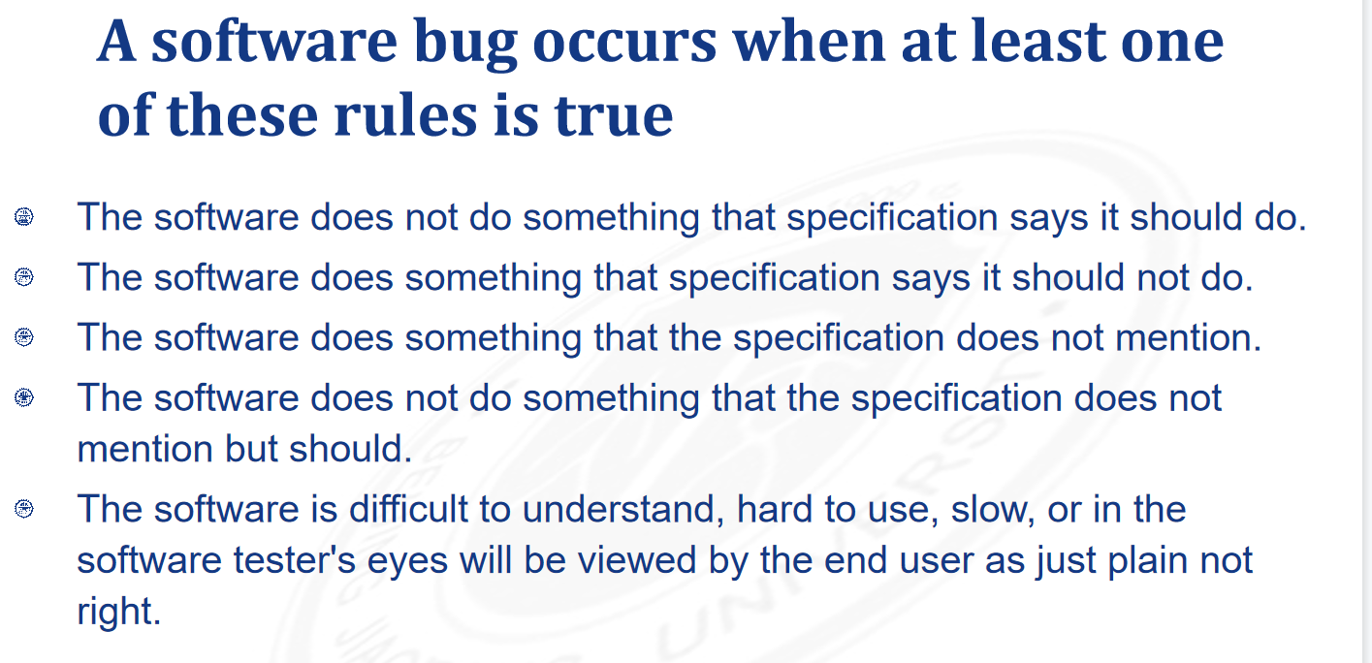

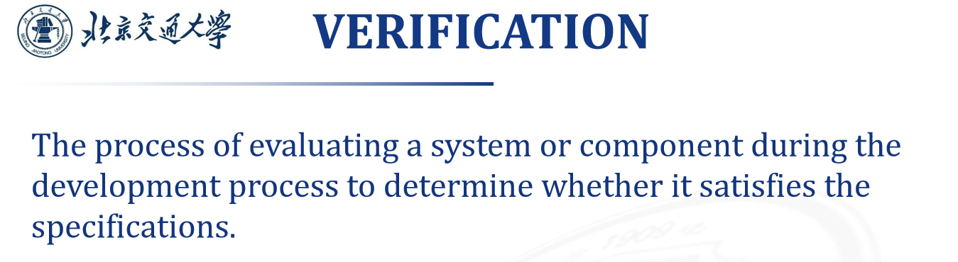

按照process的流程达到要求

/按照用户的需求达到要求

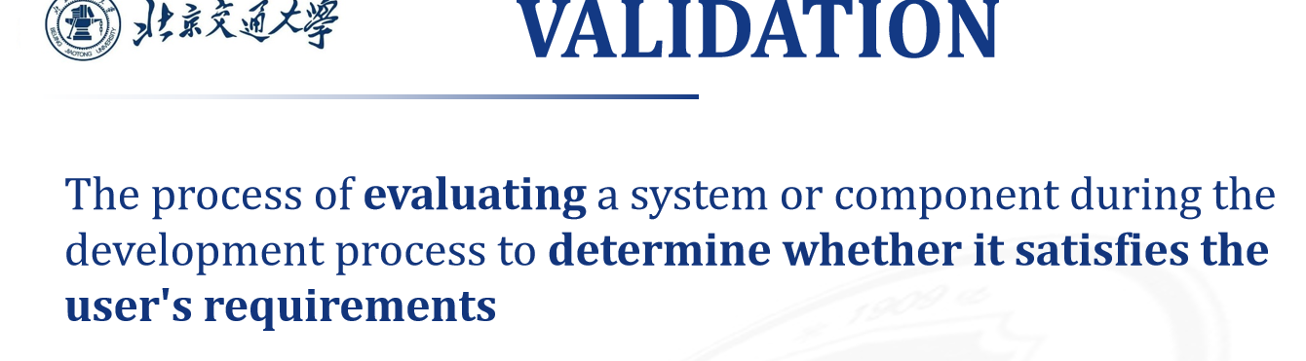

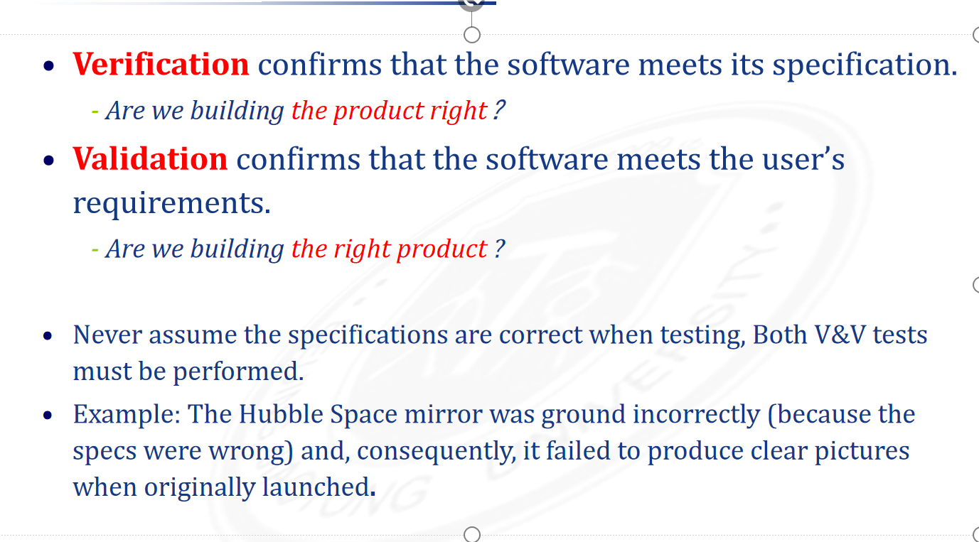

Debug与test

